# Realy ckt.

# 

# Resistor

Resistor is a passive component used to control current in a circuit. Its resistance is given by the ratio of voltage applied across its terminals to the current passing through it. Thus a particular value of resistor, for fixed voltage, limits the current through it. They are omnipresent in electronic circuits.

The different value of resistances are used to limit the currents or get the desired voltage drop according to the current-voltage rating of the device to be connected in the circuit. For example, if an [LED](http://engineersgarage.com/content/led) of rating 2.3V and 6mA is to be connected with a supply of 5V, a voltage drop of 2.7V (5V-2.3V) and limiting current of 6mA is required. This can be achieved by providing a resistor of 450http://www.engineersgarage.com/sites/default/files/Ohm%20grey%203_0.jpg connected in series with the LED.

Resistors can be either fixed or variable. The low power resistors are comparatively smaller in size than high power resistors. The resistance of a resistor can be estimated by their colour codes or can be measured by a multimeter. There are some non linear resistors also whose resistance changes with temperature or light. Negative temperature coefficient (NTC), positive temperature coefficient (PTC) and light dependent resistor ([LDR](http://engineersgarage.com/content/ldr)) are some such resistors. These special resistors are commonly used as sensors. Read and learn about internal structure and working of a [resistor](http://www.engineersgarage.com/insight/how-resistor-works).

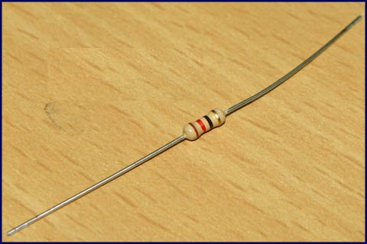

# LED

**Light emitting diodes** (**LEDs**) are semiconductor light sources. The light emitted from **LED**s varies from visible to infrared and ultraviolet regions. They operate on low voltage and power. LEDs are one of the most common electronic components and are mostly used as indicators in circuits. They are also used for luminance and optoelectronic applications.

Based on semiconductor diode, **LED**s emit photons when electrons recombine with holes on forward biasing. The two terminals of LEDs are anode (+) and cathode (-) and can be identified by their size. The longer leg is the positive terminal or anode and shorter one is negative terminal.

The forward voltage of **LED** (1.7V-2.2V) is lower than the voltage supplied (5V) to drive it in a circuit. Using an LED as such would burn it because a high current would destroy its p-n gate. Therefore a current limiting resistor is used in series with LED. Without this resistor, either low input voltage (equal to forward voltage) or PWM (pulse width modulation) is used to drive the LED. Get details about internal structure of a [LED](http://www.engineersgarage.com/insight/how-led-works).

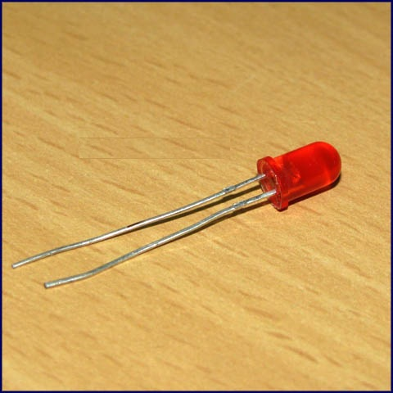

# LDR

An LDR (Light dependent resistor), as its name suggests, offers resistance in response to the ambient light. The resistance decreases as the intensity of incident light increases, and vice versa. In the absence of light, LDR exhibits a resistance of the order of mega-ohms which decreases to few hundred ohms in the presence of light. It can act as a sensor, since a varying voltage drop can be obtained in accordance with the varying light. It is made up of cadmium sulphide (CdS).

An LDR has a zigzag cadmium sulphide track. It is a bilateral device, *i.e.*, conducts in both directions in same fashion.

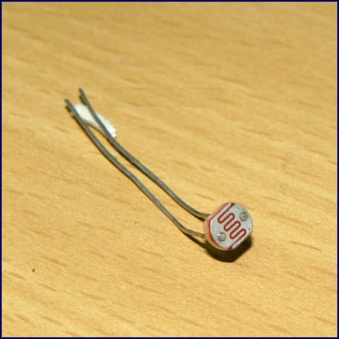

# ‘

# Transistor BC547

**BC547** is an NPN bi-polar junction transistor. A transistor, stands for transfer of resistance, is commonly used to amplify current. A small current at its base controls a larger current at collector & emitter terminals.

**BC547** is mainly used for amplification and switching purposes. It has a maximum current gain of 800. Its equivalent transistors are BC548 and BC549.

The transistor terminals require a fixed DC voltage to operate in the desired region of its characteristic curves. This is known as the biasing. For amplification applications, the transistor is biased such that it is partly on for all input conditions. The input signal at base is amplified and taken at the emitter. BC547 is used in common emitter configuration for amplifiers. The voltage divider is the commonly used biasing mode. For switching applications, transistor is biased so that it remains fully on if there is a signal at its base. In the absence of base signal, it gets completely off.

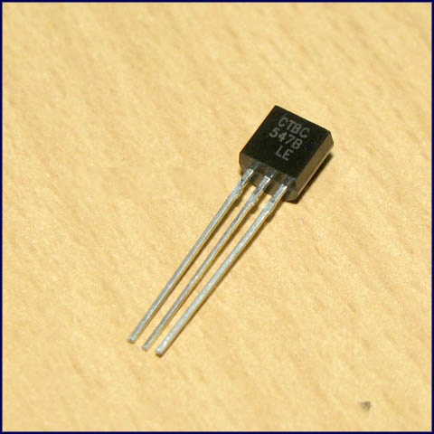

Relay Switch

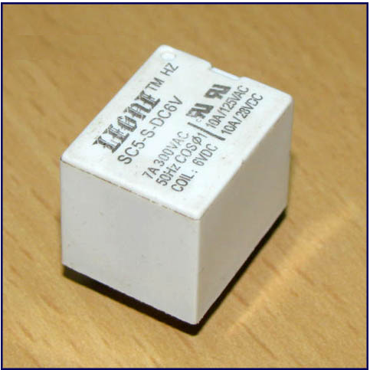

**Relay** is an electromagnetic device which is used to isolate two circuits electrically and connect them magnetically. They are very useful devices and allow one circuit to switch another one while they are completely separate. They are often used to interface an electronic circuit (working at a low voltage) to an electrical circuit which works at very high voltage. For example, a relay can make a 5V DC battery circuit to switch a 230V AC mains circuit. Thus a small sensor circuit can drive, say, a fan or an electric bulb.

A **relay switch**can be divided into two parts: input and output. The input section has a coil which generates magnetic field when a small voltage from an electronic circuit is applied to it. This voltage is called the operating voltage. Commonly used relays are available in different configuration of operating voltages like 6V, 9V, 12V, 24V etc. The output section consists of contactors which connect or disconnect mechanically. In a basic relay there are three contactors: normally open (NO), normally closed (NC) and common (COM). At no input state, the COM is connected to NC. When the operating voltage is applied the relay coil gets energized and the COM changes contact to NO. Different relay configurations are available like SPST, SPDT, [DPDT](http://www.engineersgarage.com/content/dpdt-relay) etc, which have different number of changeover contacts. By using proper combination of contactors, the electrical circuit can be switched on and off. Get inner details about structure of a [relay switch](http://www.engineersgarage.com/insight/how-relay-switch-works).

**Pin Diagram:**

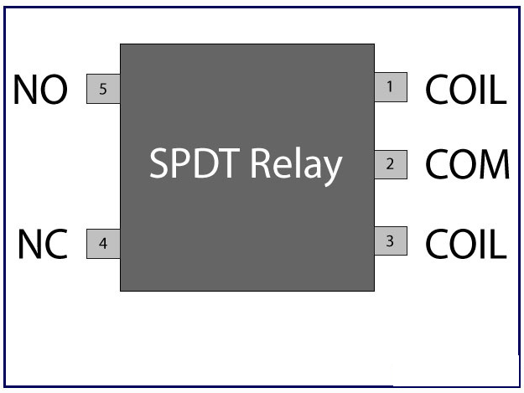

[Relay](http://www.engineersgarage.com/electronic-components/relays) is one of the most important electromechanical devices highly used in industrial applications specifically in automation. A relay is used for electronic to electrical interfacing i.e. it is used to switch on or off electrical circuits operating at high AC voltage using a low DC control voltage. A relay generally has two parts, a coil which operates at the rated DC voltage and a mechanically movable switch. The electronic and electrical [circuits](http://www.engineersgarage.com/electronic-circuits) are electrically isolated but magnetically connected to each other, hence any fault on either side does not affects the other side.

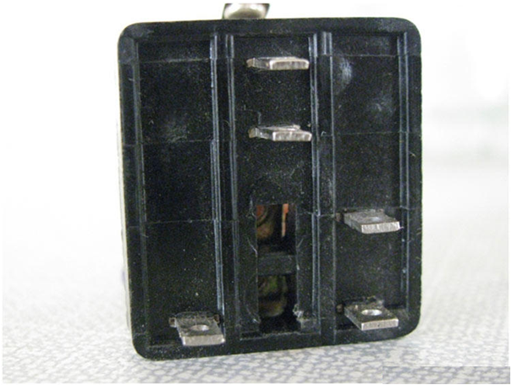

**Relay switch** shown in the image above consists of five terminals. Two terminals are used to give the input DC voltage also known as the operating voltage of the relay. [Relays](http://www.engineersgarage.com/electronic-components/relays) are available in different operating voltages like 6V, 12V, 24V etc. The rest of the three terminals are used to connect the high voltage AC circuit. The terminals are called Common, Normally Open (NO) and Normally Closed (NC). Relays are available in various types & categories and in order to identify the correct configuration of the output terminals, it is best to see the data sheet or manual. You can also identify the terminals using a multimeter and at times it is printed on the relay itself.

